## images.pngMU Logo.png

## SRI DHARMASTHALA MANJUNATHESHWARA

## COLLEGE (AUTONOMOUS), UJIRE-574240

## Computer Science Department

## Programme Name : BCA

**A PROJECT REPORT ON**

**MOBILE CLINIC**

**SUBMITTED BY:**

**DHANUSH PATEL C M**

**ROLL NO: U05SY21S0021**

**SARATH A**

**ROLL NO: U05SY21S0190**

**SUBMITTED TO**

**Ms. Divya Yadav**

**Department of Computer Science**

**Submitted on : 04-06-2024**



**SRI DHARMASTHALA MANJUNATHESHWARA COLLEGE (AUTONOMOUS), Ujire - 574240**

## DEPARTMENT OF COMPUTER SCIENCE

**Mini Project Report**

**Certificate**

This is to certify that DHANUSH PATEL C.M, SARATH A the Reg no. 210917 & 210956 of 3rd BCA has satisfactorily completed the mini-project “MOBILE CLINIC”in the Department of Computer Science, prescribed by the college during the academic year 2023–24.

(**Name to be typed) (Name to be typed)**

**Head of the Department Project Guide**

**Examiners:**

1. Ms. Divya Yadav
2. Ms. Harini

# **DECLARATION**

I hereby declare that this Mini-Project work entitled “MOBILE CLINIC”has been prepared by me during the academic year 2023 - 2024 under the guidance of Ms. Divya Yadav,Department of Computer Science, SDMCollege(Autonomous), Ujire as the partial fulfillment of BCA degree prescribed by the college.

I also declare that this mini project is the outcome of my own efforts and that it has not been submitted to any other establishments.

Signature

Dhanush Patel C.M

210917

Sarath A

210956

# **ACKNOWLEDGEMENT**

I would like to thank our principal **Dr B A Kumara Hegde** , for his support. We also thank Shailesh Kumar, HOD, Department of Computer Science, SDM College (Autonomous), Ujire, for his valuable suggestions to do the mini project work.

I would like to thank Ms. Divya Yadav,Department of Computer Science,SDM College (Autonomous), Ujire, for his/her help and for providing guidance in developing this mini-project.

Signature

Dhanush Patel C.M

210917

Sarath A

210956

**MOBILE CLINIC**

**CHAPTER 1**

**INTRODUCTION**

**INTRODUCTION**

* 1. **Introduction**

Welcome to the future of healthcare on wheels! Step into the world of convenience and accessibility with our state-of-the-art mobile clinic. Designed to bring medical care directly to your doorstep, our mobile clinic is a beacon of health on the move.

Imagine a fully-equipped medical facility on wheels, ready to cater to your healthcare needs without the constraints of traditional brick-and-mortar establishments. Whether you're in a bustling urban center or a remote rural area, our mobile clinic is committed to bridging the gap and ensuring that quality healthcare is always within reach.

From preventive screenings to immediate medical attention, our expert team of healthcare professionals is here to provide personalized care in the comfort of your community. The mobile clinic isn't just a vehicle; it's a symbol of innovation, efficiency, and a commitment to the well-being of all.

So, buckle up for a journey towards better health, where the clinic comes to you, because your well-being is our priority, and we're driving healthcare forward—one mobile clinic at a time

* 1. **Project Description**

Our mobile clinic is a fully-equipped healthcare facility on wheels, designed to address the challenges of reaching underserved populations, remote areas, and communities with limited access to traditional medical infrastructure. The project involves the conversion of a vehicle into a state-of-the-art mobile clinic, complete with examination rooms, diagnostic equipment, and telemedicine capabilities.

**1.3Problem Statement**

Despite advancements in healthcare, a significant portion of the global population still faces challenges in accessing essential medical services. This disparity is particularly pronounced in remote and underserved communities, where the absence of adequate healthcare infrastructure creates barriers to timely and quality healthcare. The problem is further exacerbated by factors such as geographical isolation, limited transportation, and socioeconomic constraints.

**1.3.2 Objective**

* **Enhance Accessibility**
* **Provide Preventive Healthcare**
* **3.Emergency Response and Disaster Relief.**
* **Community Outreach and Education.**
* **Telemedicine Integration.**
* **Cost-Effective Healthcare Delivery**
* **Collaboration with Local Stakeholder**
  1. **Scope**

The scope of a mobile clinic encompasses a wide range of healthcare services and activities, aiming to address the healthcare needs of diverse populations in various settings. Here are key aspects of the scope of a mobile clinic:

**1. Geographical Coverage**: Mobile clinics are designed to reach geographically isolated or underserved areas where access to traditional healthcare facilities is limited. The scope includes both urban and rural communities, ensuring that healthcare services are brought directly to the doorstep of those in need.

**2. Primary Healthcare Services:** Mobile clinics provide a spectrum of primary healthcare services, including general consultations, vaccinations, preventive screenings, maternal and child health services, and basic diagnostic tests. These services are essential for promoting overall community health and preventing the escalation of health issues.

**3. Preventive Healthcare:** The scope extends to preventive healthcare measures such as health education, awareness campaigns, and lifestyle counseling. Mobile clinics play a crucial role in promoting healthy behaviors and empowering communities with the knowledge needed to prevent diseases.

**4. Emergency Response:** Mobile clinics are equipped to respond rapidly to emergencies, including natural disasters, disease outbreaks, and public health crises. The scope involves providing immediate medical assistance, triage services, and emergency healthcare support to affected populations.

**5. Telemedicine and Technology Integration:** The scope includes the integration of telemedicine capabilities, allowing for remote consultations, electronic health record management, and connectivity with specialists. This extends the reach of healthcare services and enhances the ability to address complex health issues.

**­CHAPTER 2**

**SYSTEM SPECIFICATION**

**SYSTEM SPECIFICATION**

**2.1 Existing System**

As of my last knowledge update in January 2022, various organizations and initiatives worldwide have implemented mobile clinic systems to address healthcare challenges in different regions. Keep in mind that developments may have occurred since then, and new systems or updates might be in place. Here are some examples of existing mobile clinic systems:

* **Jhpiego's Mobile Outreach Services (MOS):**

Location: Implemented in multiple countries, including Kenya and Tanzania.

Scope: MOS focuses on maternal and child health services, offering antenatal care, family planning, immunizations, and health education in remote areas.

* **2. LifeNet International's Mobile Clinics:**

Location: Implemented in countries like Burundi, Uganda, and the Democratic Republic of Congo.

Scope: LifeNet International operates mobile clinics to improve primary healthcare in underserved areas, providing essential services and training for healthcare workers.

* **3. Community Health Van (CHV) in New York City:**

Location: New York City, USA.

Scope: The CHV provides services such as HIV testing, family planning, and other primary care services to individuals who may face barriers to accessing traditional healthcare.

**2.1.1 Drawbacks of existing system**

While mobile clinic systems have proven to be valuable in addressing healthcare challenges, they are not without drawbacks. Here are some common drawbacks associated with existing mobile clinic systems:

**1. Limited Scope of Services:**

- Mobile clinics often provide basic healthcare services, and the scope may be limited compared to fully equipped stationary healthcare facilities. Specialized services or procedures may not be feasible in a mobile setting.

**2. Resource Constraints:**

- Mobile clinics may face limitations in terms of medical equipment, staff, and supplies. Resource constraints can impact the range and quality of services provided, particularly in the context of emergencies or widespread health crises.

**3. Inconsistent Availability:**

- The availability of mobile clinics may be inconsistent, depending on funding, logistical challenges, and the nature of the healthcare initiative. This inconsistency can lead to periods where communities are without access to essential healthcare services.

**4. Challenges in Follow-up Care:**

- Providing continuous and follow-up care can be challenging for mobile clinics. Chronic conditions and ongoing healthcare needs may require consistent monitoring and follow-up, which may be difficult to achieve in a mobile setting.

**5. Transportation and Logistical Issues:**

- Mobile clinics depend on reliable transportation to reach their destinations. Logistical issues, such as vehicle breakdowns, fuel shortages, or challenging terrain, can disrupt the regular operation of mobile clinics.

**2.2 Proposed system**

The proposed system for an e-farming website envisions a comprehensive platform that addresses the drawbacks of existing solutions. This system aims to overcome challenges, enhance user experience, and contribute to the growth of the agricultural sector.

* Includes a user-friendly interface accessible to users with varying levels of digital literacy, ensuring ease of navigation for both farmers and buyers.
* Includes a centralized marketplace that consolidates product listings, making it convenient for buyers to access a diverse range of fresh produce in one location.
* Consists of features that specifically cater to the needs of small-scale farmers, promoting inclusivity and ensuring that all farmers can participate in the digital marketplace.
* Involves mechanisms that enhance transparency in the supply chain, allowing consumers to trace the origin and cultivation practices of the produce they purchase.
* Has robust communication channels, including forums and networking features, to facilitate interaction and collaboration among farmers, buyers, and agricultural experts.
* Fosters a sense of community by integrating social features, encouraging collaboration, knowledge-sharing, and creating a supportive environment for all users.

**CHAPTER 3**

**SPECIFICATION REQUIREMENT**

**SOFTWARE REQUIREMENT SPECIFICATION**

Creating Software Requirement Specifications (SRS) for a mobile clinic involves outlining the necessary features, functionalities, and constraints of the software system. Here's a basic outline for the SRS of a mobile clinic software:

**1. Introduction:**

-Purpose: Define the purpose of the mobile clinic software.

- Scope: Specify the boundaries of the software system, including the types of services it will support and the target user population.

- Objectives: Enumerate the key objectives the software aims to achieve.

**2.System Overview:**

-System Architecture: Describe the overall architecture of the mobile clinic software, including any client-server architecture or cloud-based components.

- Components: Identify the main components/modules of the software system (e.g., appointment scheduling, patient records, telemedicine, etc.).

**3. Functional Requirements:**

- Patient Management:

- Registration and demographic information capture.

- Electronic health records (EHR) management.

- Appointment scheduling and reminders.

**4. Non-functional Requirements:**

- Performance:

- Response time expectations for different functionalities.

- Scalability to handle varying user loads.

- Security:

- Data encryption for patient records.

- Access control and authentication mechanisms.

- Compliance with healthcare data protection regulations.

- Reliability:

- System uptime and availability.

- Backup and recovery procedures.

- Usability:

- User-friendly interface design.

- Multilingual support.

- Accessibility considerations.

- Interoperability:

- Compatibility with existing healthcare systems and standards.

- Integration with external databases or health information exchanges.

**5. Constraints:**

- Regulatory Compliance:

- Adherence to healthcare regulations and standards (e.g., HIPAA).

- Compliance with local data protection laws.

- Budget and Resource Constraints:

- Financial limitations for software development.

- Availability of technical expertise and human resources.

**3.1 Functional Requirements**

Functional requirements for a mobile clinic software system outline the specific capabilities and features that the software must have to meet the needs of healthcare professionals, support staff, and patients. Here are key functional requirements for a mobile clinic:

* **Patient Management:**
* **Clinical Services:**
* **Telemedicine Integration:**
* **Health Education:**
* **Reporting and Analytics:**
* **User Management:**

It's essential to tailor these requirements to the specific needs and context of the mobile clinic, considering factors such as the target population, types of services offered, and any regulatory or compliance standards that need to be met. Regular collaboration with healthcare professionals and stakeholders is crucial to refining and validating these requirements throughout the software development process.

**Modules of the project**

The device accommodates of two main modules:

* Doctor
* Patient

**3.1.1 Doctor:**

In a mobile clinic system, managing doctor information is a crucial aspect for ensuring effective healthcare delivery. Here are functional requirements related to doctor information in a mobile clinic software system:

* **Doctor Profile Management:**

- Create and Update Profiles: Allow administrators to create and update doctor profiles with essential information, including name, contact details, specialty, and qualifications.

-Profile Photos: Provide the option to include profile photos for easy identification.

* **Availability and Schedule:**

- Set Availability: Enable doctors to set their availability for appointments.

-Appointment Scheduling: Allow administrators or staff to schedule appointments for doctors based on their availability.

- Real-time Updates: Ensure real-time updates of doctor schedules to avoid scheduling conflicts.

* **Patient Interaction:**

- Patient Consultations: Facilitate doctor-patient interactions, including in-person consultations in the mobile clinic and virtual consultations through telemedicine.

-Patient Notes:Allow doctors to record and update patient notes during consultations.

* **Telemedicine Integration:**

- Telemedicine Consultations: Integrate telemedicine features, allowing doctors to conduct remote consultations.

-Secure Communication: Provide a secure platform for doctors to communicate with patients through telemedicine.

**3.1.2 Patient:**

Patient profile management is a critical component of a mobile clinic system, facilitating efficient healthcare delivery and ensuring accurate and accessible patient information. Here are functional requirements related to patient profile management in a mobile clinic software system:

* **Patient Registration:**

- Personal Information: Capture and store essential personal information, including name, date of birth, gender, contact details, and address.

- Demographic Information: Record demographic details, such as ethnicity, language preference, and occupation.

* **Medical History:**

**-** Past Medical Conditions: Maintain a comprehensive record of past medical conditions and surgeries.

- Allergies: Record information about allergies, including medication allergies and adverse reactions.

-Family Medical History: Include details about the patient's family medical history for a holistic understanding of health risks.

* **Medication Management:**

**-** Current Medications: Document the medications currently prescribed to the patient.

- Medication Allergies: Flag any allergies or adverse reactions to specific medications.

-Medication History: Maintain a history of previously prescribed medications and treatments.

* **Appointment History:**

**-** Appointment Records: Keep a record of past and upcoming appointments.

- Appointment Reminders: Send automated appointment reminders to patients via SMS, email, or other communication channels.

### 3.2 Non-Functional Requirements

These requirements outline criteria for assessing the functioning of a system, rather than detailing specific behaviours. They establish the limitations within which the system must operate. Non-functional requirements expand on the system's performance attributes.

#### 3.2.1 Performance

The application needs to be responsive and minimize delays, ensuring smooth interactions Without immediate interruptions. The application should efficiently utilize resources without Significantly affecting the device’s usability. It should also function in the background

#### 3.2.2 Usability

The application should be smooth to deal with and navigate within the maximum predicted manner without a delay. The application must transverse fast among its states.

#### 3.2.3 Reliability

The application must meet all the practical necessities with none sudden behaviour. At no time must the gauge output show wrong or outdated facts without alerting the consumer to capacity mistakes. The application is much less vulnerable to mistakes because it avoids mistakes as a great deal as feasible whilst coming into facts. Also, suitable mistakes messages are displayed while invalid facts are entered.

#### 3.2.4 Focused Layout

The updated system will minimize confusion by employing a focused layout. This implies that it will present only pertinent information for the ongoing task, while excluding any unrelated details.

#### 3.2.5 Maintainability

The software program must be written truly and concisely. The code may be nicely documented. Particular care may be taken to layout the software program modularly to make sure that upkeep is smooth.

#### 3.2.6 Portability

Moving installed program files to a similar architecture computer. Reinstalling a program from distribution files on a similar architecture computer. Creating executable programs for various platforms using source code; this process is commonly known as "porting".

#### 3.2.7 Response time

The time taken with the aid of using the device to finish a project given with the aid of using the consumer should be very much less. The software should reply right away to the project requested.

### 3.3 Feasibility study

Feasibility looks at is a process that identifies, describes and evaluates software and selects the quality software function for the job. An estimate is made whether or not the recognized customers want can be glad the use of the cutting-edge networking centres and hardware technology. The look at will determine whether or not the proposed application software may be fee powerful from a commercial enterprise factor of view and if it could be advanced the use of the given present budgetary constraints.

The key issues concerned with inside the feasibility evaluation of our proposed software is the subsequent:

* Operational Feasibility
* Technical Feasibility
* Economic Feasibility
* Schedule Feasibility

#### 3.3.1 Operational Feasibility

Operational feasibility is essential because it guarantees that the venture advanced is a hit one. The operational feasibility of this venture is excessive for the reason that it's far consumer pleasant and the software affords all of the predicted outputs to the consumer.

#### 3.3.2 Technical Feasibility

Technical feasibility evaluation makes an evaluation among the extent of era to be had and this is wanted for the improvement of the venture. The degree of era includes the elements like software program gear, and platform advanced and so on. Since, the assets for the improvement of the venture are to be had, the venture is technically feasible.

#### 3.3.3 Economic Feasibility

This is the maximum essential a part of the venture due to the fact the phrases and situations for enforcing the venture must be economically feasible. The hazard of finance does now no longer exist as the prevailing hardware this is can easily use in website application and the software program is freed from fee. So, it's far believed that the device is economically feasible.

#### 3.3.4 Schedule Feasibility

Schedule feasibility is described because the probability of a venture being finished inside its preferred timeframe. Since this venture has an excessive probability completion with the aid of using the preferred due date, time table feasibility is taken into consideration to be excessive.

**3.4 Hardware Requirements**

Processor :12th Gen Intel (R) Core (TM) i5-1235U 1.30GHz

RAM : 8GB RAM

Input Devices : Keyboard, Mouse

**3.5 Software Requirements**

Operating System : Windows 11

Developing Tool :VS code

Database Language: MySQL

Language :HTML, php,javascript, Python

Framework: Bootstrap

**CHAPTER 4**

**SYSTEM DESIGN**

**SYSTEM DESIGN**

The system design for the E-Farming website involves a comprehensive approach to fulfill the outlined requirements. It includes the creation of a user-friendly interface, efficient database management, robust security measures, and an overall system architecture that facilitates seamless communication and transactions between farmers and buyers.

**4.1 Use Case Diagram**

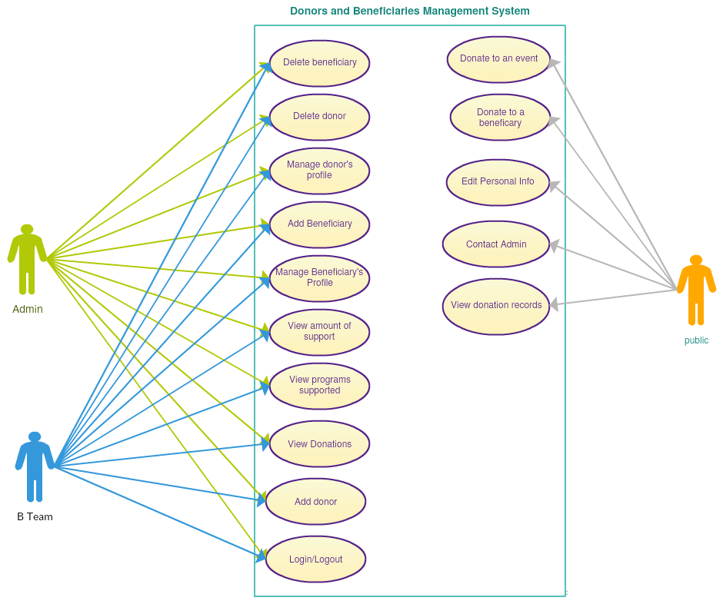

**Actors:**

1. **Docter:** The person interested in buying fresh produce.

2. **Patient**: The individual selling fresh produce on the E-Farming website.

The primary goal of this use case is to outline the steps involved when a buyer purchases fresh produce from a farmer through the E-Farming website.

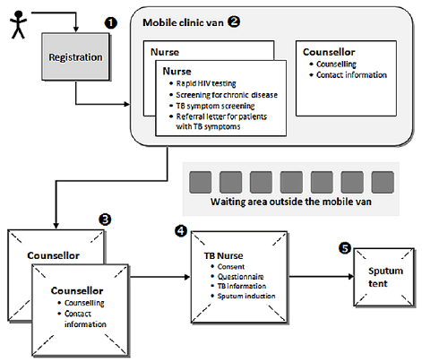

FIG 4.1.2 FLOW USE CASE

**Main Flow:**

* Buyer Logs In: The buyer accesses the E-Farming website and logs in to their account.
* Browsing Products: The buyer navigates to the E-Marketplace section to explore available products.
* Product Selection: After browsing, the buyer selects the desired fresh produce from a farmer's listing.
* Viewing Product Details: The buyer views detailed information about the selected product, including images, descriptions, and pricing.
* Adding to Cart: The buyer adds the chosen product to their shopping cart.
* Checkout: The buyer proceeds to the checkout section to review the selected items and confirm the purchase.
* Payment: The buyer securely makes the payment using available payment options.
* Order Confirmation: The system confirms the successful transaction and generates an order confirmation for the buyer.
* Notification to Farmer: Simultaneously, the farmer receives a notification of the purchase.
* Product Preparation: The farmer prepares the purchased fresh produce for delivery or pickup.
* Delivery/Pickup: The buyer either receives a delivery of the fresh produce or arranges for a pickup, as per the agreed terms.

**Alternative Flow**: If the buyer encounters any issues during the checkout process, they can contact customer support for assistance.

**Exception Flow**: If the selected product is no longer available (e.g., sold out), the buyer is notified and may choose an alternative product or wait for restocking.

This use case illustrates the straightforward process of a buyer purchasing fresh produce through the E-Farming website, emphasizing the ease of use and efficiency in connecting buyers with local farmers.

**4.2 WORK FLOW DIAGRAM**

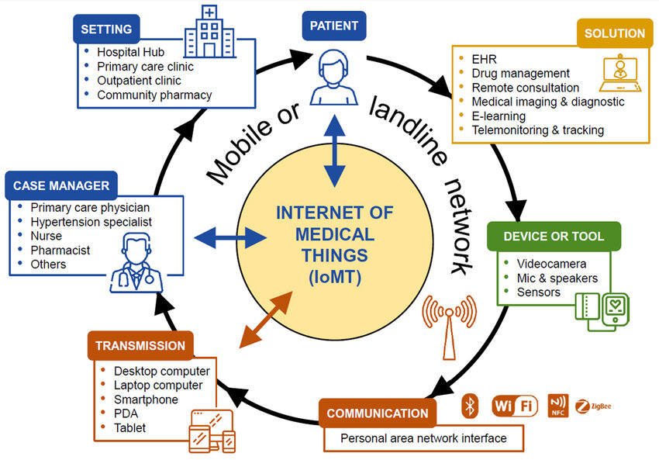

FIG 4.2 WORKFLOW DIAGRAM

**CHAPTER 5**

**SYSTEM IMPLEMENTATION**

## IMPLEMENTATION

Creating an implementation for a mobile clinic involves several key steps. Here's a simplified outline to get you started:

**1. Define Objectives and Services:**

- Clearly outline the goals of your mobile clinic.

- Identify the medical services you plan to offer on the go.

**2. Legal and Regulatory Compliance:**

- Ensure compliance with healthcare regulations and obtain necessary licenses.

- Establish protocols for patient confidentiality.

**3. Mobile Clinic Setup:**

- Choose a suitable vehicle and equip it with necessary medical facilities.

- Include examination rooms, basic diagnostic tools, and storage for medications.

**4. Technology Integration:**

- Implement an electronic health record (EHR) system for efficient record-keeping.

- Consider telemedicine options for remote consultations.

**5. Staffing:**

- Recruit qualified medical professionals (doctors, nurses, technicians).

- Train staff on mobile clinic procedures and emergency protocols.

**5.1 Software Tools Used**

Visual studio code.

### 5.2 Programming Technology

HTML

PHP

Python

Java script

### 5.3 Project implementation requirements

This project is working using visual studio code platform. For this project to run it should have Xampp to work on database (to store data), here we have used python, CSS, Bootstrap.

Implementation of an e-farming website requires:

* + Secure user registration and login functionality.
  + Encryption techniques to protect sensitive user data.
  + Robust search engine and filtering options for users to find products easily.
  + Optimized search functionality for performance.
  + Secure payment gateway for online transactions.

**5.4ScreenShots**



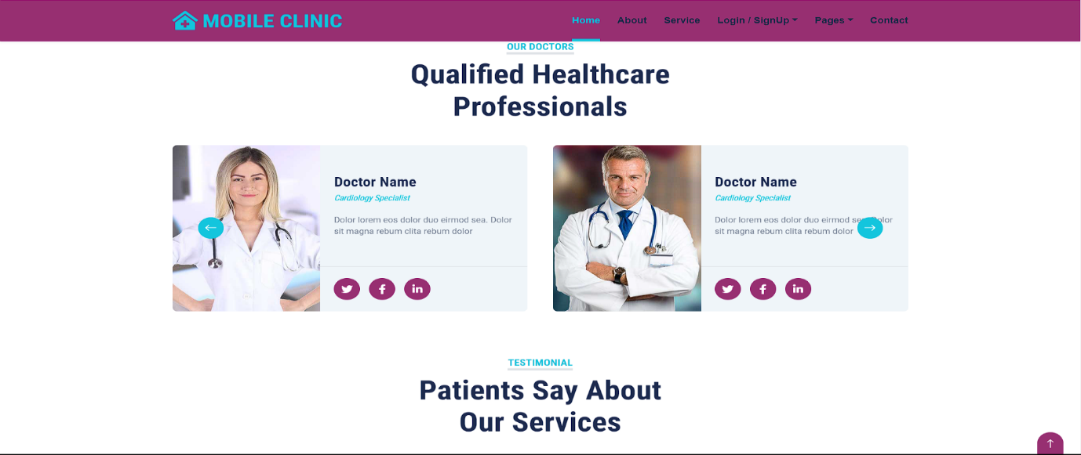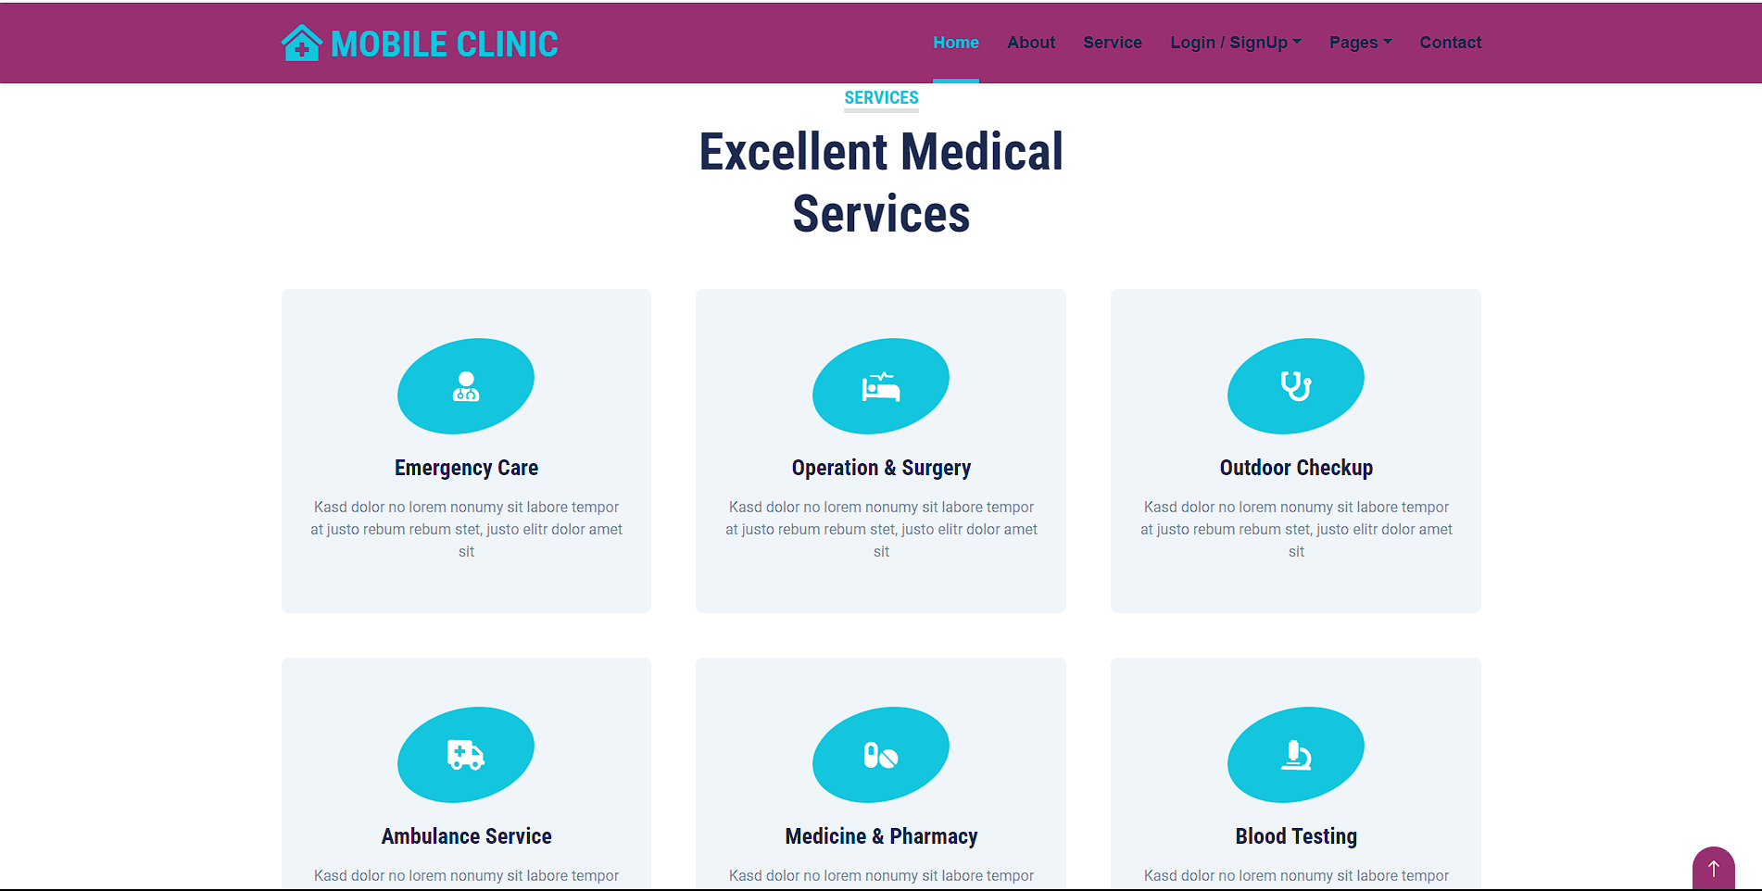

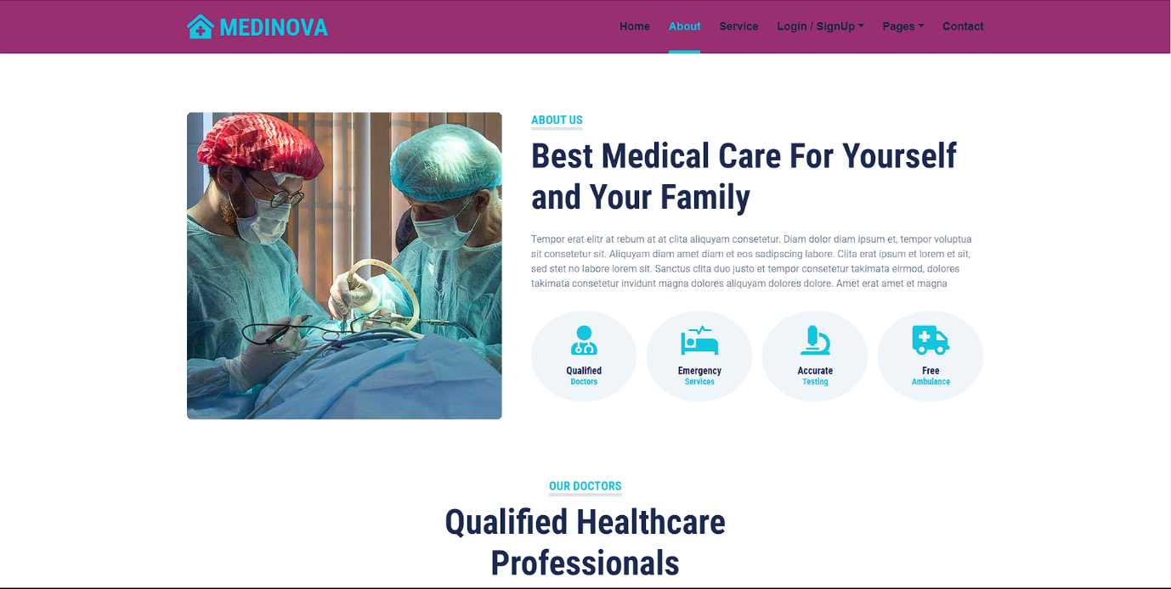

**CHAPTER 6**

**TESTING**

**TESTING**

## 6.1. Introduction

Software testing involves running a program to uncover software bugs. It's a crucial aspect of ensuring software quality and confirming its accuracy. High-quality software boosts customer confidence and benefits business outcomes. Essentially, top-notch products have no defects, which stem from a robust testing process.

Testing the product enhances its value by increasing its quality and reliability. Elevating reliability involves identifying and rectifying errors. Therefore, the approach should not be to test a product to demonstrate its functionality, but to assume that the program contains errors and then test it to uncover as many errors as possible.

The primary aim of tes is to identify flaws in requirements, design, documentation, and code at the earliest stage. Testing should ensure that the software product delivered to the customer is free of defects. All tests should be linked to customer requirements. Test cases must cover both unexpected and invalid scenarios, as well as anticipated and valid input conditions. A crucial aspect of a test case is specifying the anticipated outcome or result. A well-designed test case is one that holds a strong likelihood of uncovering errors that have not been identify yet.

### 6.1.1 Manual Testing

Manual testing involves testing software manually, without automation tools or scripts. In this approach, the tester simulates an end-user's role to identify unexpected behavior or defects. Manual testing encompasses various stages, including unit testing, integration testing, system testing, and user acceptance testing.

Testers employ test plans, test cases, or test scenarios to assess software and ensure thorough testing coverage.

Exploratory testing is a component of manual testing, where testers actively explore the software to uncover errors.

### 6.1.2 Unit Testing

Developers perform this type of testing before handing over the software to the testing team for formal execution of test cases. Unit testing is carried out by the developers on individual units of source code assigned to them. Developers use separate test data compared to the quality assurance team's test data.

Tests which might be done for the duration of the unit checking out within the app are defined below:

* **Module Interface check:** During module interface checks, the focus lies on confirming if data enters and exits the program unit or module correctly. For example, the registration information of the user should be accessible from the layout to the relevant controller, and then flow from the controller to the model.
* **Boundary situations:** Many software programs frequently encounter issues at boundary-related conditions. Therefore, testing these boundary conditions is crucial to ensure the program functions effectively at these limits. For instance, when dealing with if…else if…else constructs, all possible scenarios are examined within the application. Similarly, when working with loops, it is ensured that the loops are not infinite and terminate once the condition becomes false.
* **Error coping with paths:** These tests are conducted to verify the effective handling of errors.

### 6.1.3 Integration Testing

Integration testing involves assessing combined components of an application to ensure their proper functioning. This can be done using two approaches: Bottom-up integration testing and Top-down integration testing. In this project, the Bottom-up integration approach is followed. Here, testing begins with unit testing and progresses to tests of progressively higherlevel combinations of units, referred to as modules or builds.

After integrating all the distinct modules within the app, the application underwent testing for the following:

* Switching between screens
* Successful storage of layout data in the database
* Accurate retrieval and display of data from the database within layouts
* Proper functionality of menu items

### 6.1.4 System Testing

System testing evaluates the entire system. After integrating all components, the complete e software undergoes comprehensive testing to ensure it align with the required quality standard The application worked through website, and all its functions were rigorously tested for various input scenarios. Multiple test cases were executed to verify if the application operated as intended, with no instances of crashes or unexpected behaviour.

**6.2 TEST CASES**

**Functional Test Cases**

|  |  |  |  |  |  |  |  |
| --- | --- | --- | --- | --- | --- | --- | --- |
| **TC**  **Id** | **Test Case**  **Name** | **Test Case**  **Description** | **Test Steps** | | | | **Test**  **Status P/F** |
| **Steps** | **I/P Given** | **Expected**  **O/P** | **Actual O/P** |
| TC  01 | Login | To verify that the farmer or buyer has entered valid password | Search with valid Phone number and  password | Valid  Phone number and password | Login  successful | Login successful (moves to farmer or buyer page) | Pass |
| Login | To verify that the farmer or buyer has entered valid password | Login with invalid  password | Invalid  password | Login failed | Login failed | Pass |
| TC  02 | Search | Search for a product that is not available | Enter invalid product name | Invalid product name | No match found | No match found | Pass |
| TC  03 | Input | Add new produce | Farmer will add his new produce | Valid data | Update  successfully | Update  successfully | Pass |

**CHAPTER 7**

**CONCLUSION AND FUTURE ENHANCEMENT**

**Future Enhancements:**

* **Mobile Application Development:** Extend the platform's accessibility by developing a mobile application, enabling users to engage seamlessly on various devices.
* **Advanced Analytics:** Implement advanced analytics tools to provide farmers with insights into market trends, helping them make informed decisions.
* **IoT Integration:** Explore the integration of Internet of Things (IoT) devices to monitor farm conditions, enabling data-driven decision-making for farmers.
* **Blockchain for Transparency:** Implement blockchain technology to enhance transparency in the supply chain, providing consumers with a verifiable and trustworthy source of information.
* **Global Expansion:** Consider expanding the platform's reach globally, fostering connections between farmers and buyers across different regions.
* **Virtual Reality (VR) Farm Tours:** Introduce VR farm tours, allowing users to virtually explore farms and gain a deeper understanding of agricultural practices.
* **Localized Language Support:** Incorporate localized language support to cater to a broader audience, including farmers and buyers from diverse linguistic backgrounds.
* **Smart Contracts:** Explore the implementation of smart contracts to automate and secure transactions between farmers and buyers.
* **Enhanced Community Features:** Further enhance community-building features, such as discussion forums and expert consultations, to foster collaborative learning and knowledge-sharing.

**CHAPTER 8**

**REFERENCES**

**8.1 References**

* https://en.wikipedia.org/wiki/Static_web_page
* https://en.wikipedia.org/wiki/Web_application
* https://www.apachefriends.org/download.html
* https://www.python.org/
* https://www.djangoproject.com/
* https://g.co/kgs/ePHUyB
* https://www.google.com/
* https://pypi.org/project/pip/